Part 1:
Read the following
- https://opentextbc.ca/dbdesign01/chapter/chapter-1-before-the-advent-of-database-systems/
- https://opentextbc.ca/dbdesign01/chapter/chapter-2-fundamental-concepts/
- https://opentextbc.ca/dbdesign01/chapter/chapter-3-characteristics-and-benefits-of-a-database/
Review the material provided on D2L in learning module “Introduction”
Listen to the following
https://www.linkedin.com/learning/programming-foundations-databases-2015/exploring-databases-and-database-management-systems?u=76116202

Complete the following:
- What is a DBMS?
This is a collection of programs that enables users to create and maintain database and control access to them
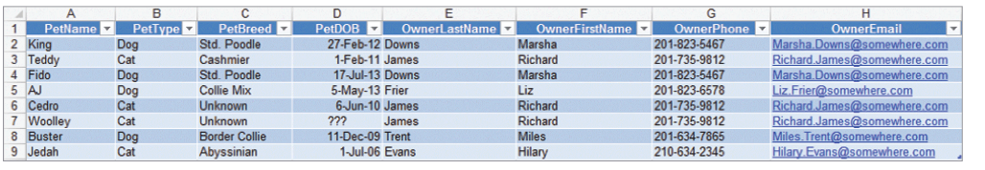
- The figure below shows a list that is used by a veterinary office. Describe three modification problems that are likely to occur when using this list.

- Deletes
If I wanted to delete one record from this table there is no strong condition like a unique identify to stop me from deleting all the records instead of one. Although the pet Name in this table is unique, it is bad to use something as name as a unique identifier because it’s possible for two different pets to have the same name.
- Updates
If I wanted to update this table there is no strong condition like a unique identify to stop me from updating all the records instead of one.
- Reads
This would be bad on performance because there’s no unique identifier that points me to the right record quickly.

- For the spreadsheet listed below, identify the number of themes you think the spreadsheet includes
- Pet Information
- Owner Information

- Name of Spreadsheet: veterinary office
Column Headings: PetName, PetType, PetBreed
Themes: Pet Information

Column Headings: OwnerFirstName, OwnerLastName, OwnerPhone, OwnerEmail
Themes: Owner Information

Part 2: Career Perspectives

Read:
- https://www.lifewire.com/starting-a-career-in-databases-1019627
- https://www.bls.gov/ooh/computer-and-information-technology/database-administrators.htm
Watch and listen:
- https://www.candidcareer.com/video-database+administrator,093b5eecacda3cf61c3a,GGC
Complete the following:
Conduct additional research as needed. In your own words, briefly summarize what database administrators do and what would you (or someone like you) need to do to get such a position.
What do DBAs do? DBAs use specialized software like SQL Server, MySQL, Oracle to manage, secure and administer the data of a company.
How do you qualify for a DBA position? Firstly, you’ll need a degree in IT, a certification or two but this is usually not required by all companies. An example of a certification to get would be the MCSA 2016. Lastly and most important you need experience.

